**APPLICATION FORM - FILMING IN A PUBLIC PLACE IN COUNTY WICKLOW**

|  |  |
| --- | --- |
| **Contact Details** | |
| Name & Address of Production Company: |  |
| Title of Production: |  |
| Contact Number: |  |
| Email: |  |
| Location Manager or Production Manager: |  |
| **Proposed Date, time, location** | |
| Please refer to the attached map and tick relevant Municipal District: | Baltinglass ⃝ Greystones ⃝  Wicklow ⃝ Arklow ⃝  **(For Bray Area email BrayMD@wicklowcoco.ie)** |
| Exact Location within MD:  (Screen Wicklow cannot approve filming on private lands therefore the applicant must ensure that the location is public land prior to submitting this application) |  |
| Proposed date(s) of filming: |  |
| Exact time(s): | Start:  Finish: |
| No. of Crew/Cast on location: |  |
| **Details on Production** | |
| Production Budget Estimate: | Less than €1M $⃝$ Between €1M - €5M ⃝  Over €5M ⃝ |
| Production Type | Film ⃝ Commercial ⃝  Series ⃝ Documentary ⃝  Other ⃝ |
|  | National ⃝ International ⃝ |
| Please give details of any specific requirements |  |
| Will road / footpath / parking bays, closure be necessary? |  |

|  |  |  |
| --- | --- | --- |
| **Equipment** | | |
| What type of equipment will be used for filming? |  | |
| Total number of vehicles on location |  | |
| Are you planning on using a Drone for your filming? * PLEASE SEE TERMS & CONDITIONS (2). |  | |
| **Insurance Details** | | |
| **Public Liability Insurance** | **Yes ⃝ No ⃝** | |
| Name of Insurance Company/Insurance Broker |  | |
| Policy Number |  | |
| Expiry Date |  | |
| **Employers Liability Insurance** | **Yes ⃝ No ⃝** | |
| Name of Insurance Company/Insurance Broker |  | |
| Policy Number |  | |
| Expiry Date |  | |
| Is a Health and Safety Plan Required | **Yes ⃝ No ⃝** | |
| *Please ensure Wicklow County Council is indemnified on both policies | | |
| *No Permission to film will be granted until all required paperwork is received with completed application form. | | |
| **Declaration**  I, the undersigned confirm that the above information is true and factual | | |
| Signature: | |  |
| Date: | |  |

**Terms and Conditions**

1. **Insurance**

Wicklow County Council require a copy of the relevant insurance policy, cover should exceed €6.5million in respect of public liability and €13m in respect of employer’s liability. The insurance policy must include an indemnity to Wicklow County Council.

1. **Drone Usage**

Wicklow County Council will require –

* Proof of permission from the Irish Aviation Authority if you are using a drone to film. (All drones over 1kg in weight must be registered with the Irish Aviation Authority).
* Evidence of drone operations licence and Insurance.

1. **Traffic Management**

In the event that there will be disruption to the normal flow of traffic in the area:

* The production company is obliged to liaise with the local Gardai.
* A **Traffic Management Plan**, designed and maintained on site as required by the current Chapter 8 of the Traffic Signs Manual, must be submitted to Wicklow County Council with this application.
* All vehicles must be parked legally and must not block driveways, footpaths or cycleways or otherwise obstruct private properties or road users.

1. **Road Closures**

* There is an application form and a formal procedure to be carried out in order to close any public road. The application process will take eight weeks minimum.

A copy of the application form can be accessed here: <https://www.wicklow.ie/Portals/0/adam/Documents/NSLQuZ_I3Ee8TzsXhAP2kA/Link/Application%20form%20Road%20Closure-1.pdf>

1. **Environmental Nuisance**

* Noise generated by filming and film-related activities should be maintained below 55dB(A) Leq (1 hour), as serious annoyance can be expected above this level.  Outside of 8am to 7pm this level should not exceed 45dB(A) Leq (1 hour).
* Activities likely to cause nuisance should not take place outside of the hours of 8am to 7pm. Weekend and public holiday activity should be avoided where possible.
* Engines should not be idling on site.
* Generators should not run through the night (silent generators should be used, if possible).
* Lighting should be managed and directed to avoid illuminating private property.
* The number of vehicles and plant on site should be minimised.
* Locations for welfare facilities, canteens, etc should be selected to minimise potential for disturbance.

1. **Credits & Use of Imagery**

* Production company to facilitate Photo opportunities with Screen Wicklow during filming on location.
* Production company to supply and allow use of promotional imagery/ videos to Screen Wicklow.
* Wicklow County Council to be acknowledged in the credits.

1. **Filming on beaches**

* Beach & Foreshore Bye-laws must be strictly adhered to.
* The beach must be left free of litter and in the same condition as when entered.
* All damage must be repaired to the satisfaction of Wicklow County Council.
* Any Company wishing to film on or in the water must provide their own rescue boat/ water safety personnel.
* If filming on Brittas Bay Beach North or South an Appropriate Assessment Screening Report and Ecological Impact Assessment Report must be prepared and submitted with this application.

1. **National Parks Areas (Wicklow Mountains)**

Where the proposed filming location is within a Special Area of Conservation (SAC) or Special Protected Area (SPA) the producer must obtain the appropriate environmental screening whether on State owned land or on private. If queries do arise, please contact the OPW Conservation Ranger on email [wmnp@housing.gov.ie](mailto:wmnp@housing.gov.ie)

1. **Public Consultation**

* In all cases, consultation with immediate neighbours (business and residential) is required. Residents to be facilitated wherever possible.
* The Production Company should nominate a designated point of contact for local residents and businesses.

1. **Fees**

* From time-to-time Wicklow County Council may ask the production company to make a financial contribution to local community groups where filming is taking place.
* An application Fee of €130 (exclusive of VAT) will apply to this application and must be paid via bank transfer, details are below:

Account No.     15587561

Sort Code         90-67-34, Bank of Ireland, Wicklow.

BIC                    BOFI IE2D

IBAN                 IE78BOFI 90673415587561

**Wicklow Municipal District Areas**

(Bray, Greystones, Wicklow, Arklow, Baltinglass)

**Note: Filming in the Bray Municipal District is administered separately. Contact BrayMD@wicklowcoco.ie**

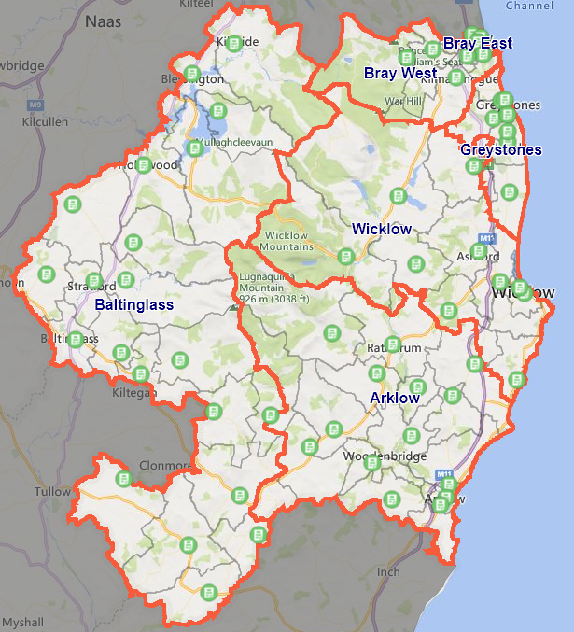

<https://wicklow.maps.arcgis.com/apps/webappviewer/index.html?id=ba5e4b8446af46908b84da7ae2060827>